

VIB-UGent Summer School on Plant Genome Editing
2025
Laboratory notebook
Student:
Instructors: Thomas Jacobs & Lab

Contents
Background information 2
Endogenous target 3
Target design—Thursday 3
Testing endogenous target genotyping assay—Tuesday 9
Sanger analysis—Wednesday 10
Endogenous target Golden Gate reactions—Wednesday 12
Colony PCR of endogenous target—Thursday 13
Sanger analysis—Friday 14
crRNA off-target reporter cloning 16
Off-target Golden Gate cloning—Friday 16
Fluorescent colony counts—Tuesday 17
Colony PCR of reporter—Tuesday 18
Gel electrophoresis—Wednesday 18

Background information
In this course you are going to perform two Cas12a base editing (A-to-G) experiments.
- Everyone will each design 1 PCR amplicon (2 primers) and 1 crRNA (2 primers) targeting an endogenous gene in the E. coli genome. The approach and methods used here can be used in practically any genome editing experiment in any species.
- Everyone will also contribute to an off-target experiment using a fluorescent reporter vector. We know we can turn the fluorescent reporter ‘on’ by base editing. We are going to explore Cas12a off-targeting by introducing crRNAs containing mismatches and evaluating whether or not they restore fluorescence.
Use this printed worksheet and the digital version to keep track of your results. Check things off as you go. Record important information. Similar protocols will be used for both experiments. Pay attention to where you are in this notebook.
In addition to this document, we have a Geneious folder with everything you need. You can download it from there googledoc folder. We will use this folder to share other materials.
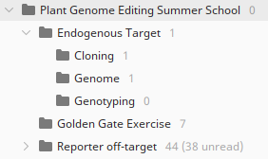
E. coli is a haploid organism with 1 circular chromosome. There genetic resources are excellent. Be sure you have imported the Geneious file into your Geneious. The E. coli genome is found in the ‘Genome’ folder. You can also go to this genome browser for more information.
When looking at the genome in Geneious, you can zoom in all the way to individual bases. There are annotations on the sequences to tell you what the sequence codes for. In yellow is the coding sequence (CDS) and in green the gene name. There are other DNA elements annotated as well, such as non-coding RNAs, tRNAs, rRNAs, etc.
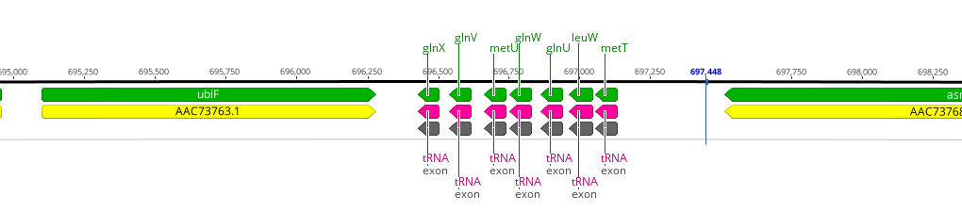

Endogenous target

Target design—Thursday
Choose your target
Explore the genome sequence and select one gene as your target. It can be any gene. Provide a brief rationale and what you expect to happen upon mutation of this gene.
Gene: [PASTE YOUR GENE NAME HERE]
Rationale:

crRNA design
Go into Geneious. Click on your gene annotation to select it and extract it from the genome. Move to the ‘Endogenous Target’ folder.
Start by designing crRNAs to your gene model. In Geneious, select the region of the gene you want to target using your cursor. See the next figure. Go to Annotate & Predict > Find CRISPR Sites… Make sure you use the correct target site. Uncheck the activity scoring. Use the “Genome” folder as an off-target database. Set maximum number of mismatches to 3. You will receive a notification that there is 1 exact copy, this is your target gene so the message can be ignored. The crRNAs are color coded by their specificity score. Green = good (few or no off targets) and yellow to red = many off targets.
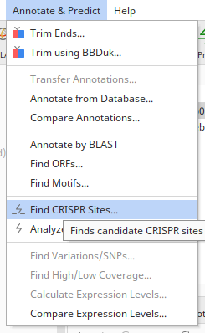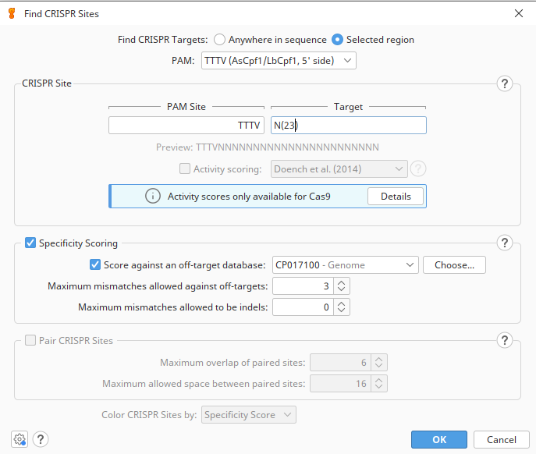
And the result
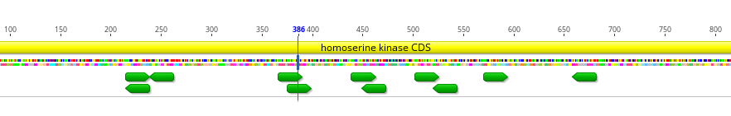
Green is good. Yellow to red indicates off targets in the off-target database. All of these crRNAs are specific to this gene.
Now we need to find crRNAs that can be used for base editing. ABEs generate A-to-G mutations. With Cas12a, the editing window is between positions 7 and 12 away from the PAM (red boxes). For example, both of these crRNAs have As within the window (yellow highlight).
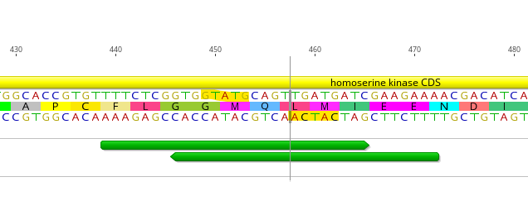
11
7
PAM

Choose 1 crRNA sequence, including PAM, and paste the sequence here:
Format is 5’- PAM…
crRNA: 5’-
What is the expected repair product and amino acid changes? Highlight changes.
Repair product (DNA):
Repair product (AA):

Primer design
After identifying a suitable crRNA, now we need to check we can genotype it by PCR and sequencing. Geneious has Primer3 built in, so we will use that to design new primers.
The primers will be used for Sanger sequencing followed by EditR analysis, so they should amplify a region between 300 and 800 bp in length and be approximately 100 bp away from the primer binding site.
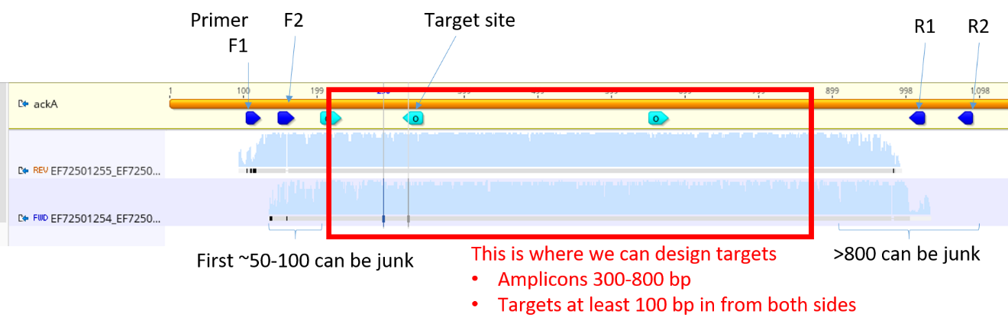
Select your candidate crRNA and set your primer design to the following criteria. Be sure to set it to return 1 primer pair.
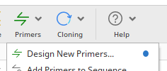
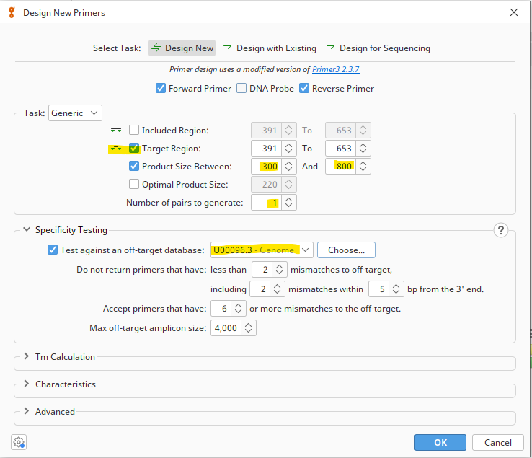

The result:
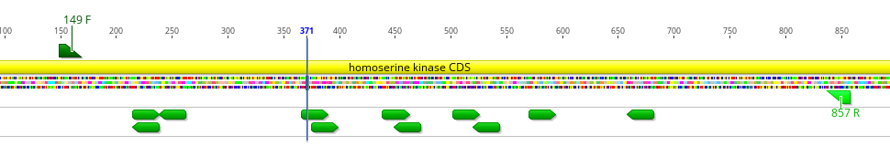
Check that your primers are in the place you need them. Paste your primer sequences below and into the googlesheet.
Student | Primer Name | Sequence 5’ – 3’

IF YOU CANNOT DESIGN APPROPRIATE PRIMERS, GO BACK AND SELECT A NEW CRRNA

In silico cloning
Everything that can be done at the bench can be modelled in your computer within minutes. Get in the habit of first performing your in silico cloning before ordering primers. This is the fastest way to identify potential design issues and save yourself weeks or months of work.
We will clone the crRNA with an annealed-oligo strategy. Two oligos are required for each crRNA, one in the sense and the other in the anti-sense direction. 4-nt overhangs (ssDNA) are added to allow for ligation to the entry vector. The ccdB gene is included as a negative-selection marker (deleted for clarity). Any E. coli cell containing ccdB will die, thereby removing empty-vector contamination.
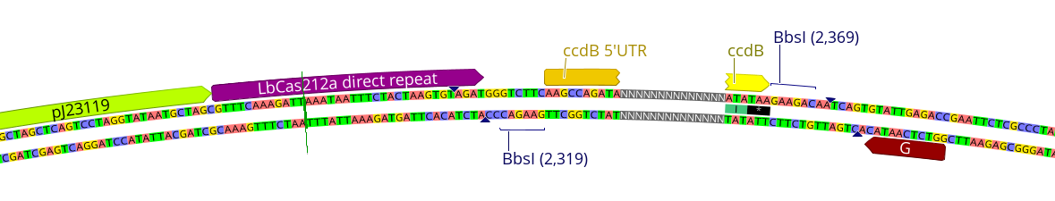The vector we are using is called pGGP-ABE and is in the “Endogenous Target > Cloning” folder. It contains a pair of BbsI restriction sites for Golden Gate cloning.
Annealed oligos format
Sense: 5’ AGAT NNNNNNNNNNNNNNNNNNNNNNN 3’
Antisense: 3’ NNNNNNNNNNNNNNNNNNNNNNN AGTC 5’
Create the oligos you will order by adding the overlaps to your spacer sequences.
Student | Primer Name | Sequence 5’ – 3’
Import these into Geneious as oligos (primers) or Add >New Sequence > specify type ‘Primer’.
Perform annealed-oligo cloning to create your dsDNA insert. Select your two oligos and go to Tools > Workflows > Annealed oligo cloning. See next page for settings.
Select your annealed oligo product and perform golden gate assembly into pGGP-ABE backbone. You may need to reverse-complement your annealed oligo for the overhangs to match the backbone.
Potential issues
- BbsI site located within crRNA
- Primers are not reverse-complement of each other
- Did not select the correct backbone
- Did not select the correct enzyme -> should be BbsI
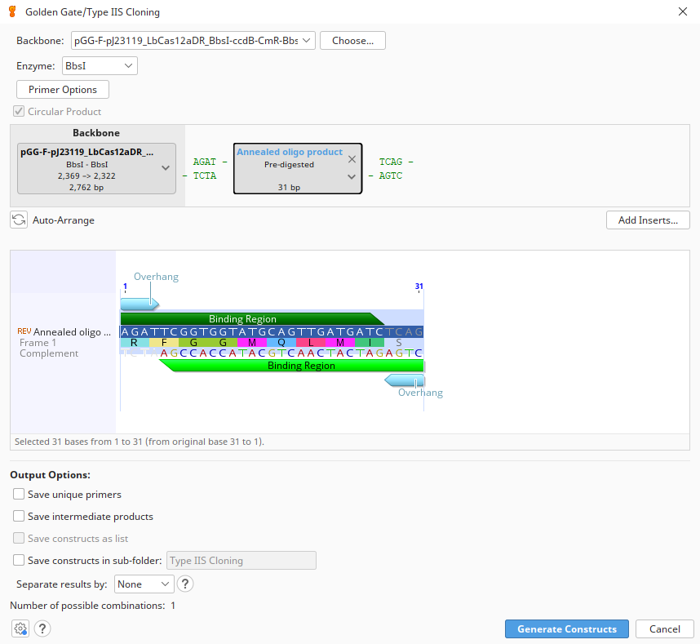

Quality Control Questions
- How long are your crRNA oligos?

- What is the final length of your new plasmid?

- What is the distance from your primers to the predicted editing site?
Amplicon1: F R

If everything looks good, paste your oligo sequences below and into the googlesheet.

Testing endogenous target genotyping assay—Tuesday
Do your designed primers work? Perform a PCR with your primers and wild-type E. coli to test them. We will use the colonies from the off-target analysis.
Resuspend your primers to a concentration of 100 µM.
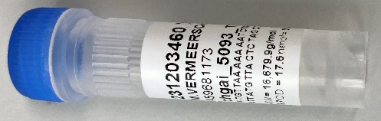
For example, this oligo is 17.6 nmol. To make a 100 µM stock, add 176 µl of water or buffer (e.g. 10 mM Tris-HCl).
Steps:
- Spin tubes down with mini-centrifuge ~10 seconds
(this ensures the oligo pellet is at the bottom of the tube)
- Add correct amount of water or buffer
- Cap and mix by shaking and/or vortex
- Spin tubes down with mini-centrifuge ~10 seconds

Make 10 µM working stocks.
Per primer, add 90 µL water and 10 µL of your 100 µM oligos in a fresh 1.5 mL tube. Remember to label your tube.
PCR protocol, per amplicon:
Component | 1x | 3x
Allin Red Taq 2xMM | 5 µL | 15
F primer 10 µM | 0.2 µL | 0.6
R primer 10 µM | 0.2 µL | 0.6
H₂O | 4.6 µL | 13.8
Total | 10 µL
Temp | Time
95°C | 3:00
95°C | :15 | 30X  cycles
60 °C | :15 | 30X  cycles
72°C | :30 | 30X  cycles
72°C | 5:00
12°C | ∞
Controls: include 1 no-template (NT) control.
Record your expected PCR fragment size:
Perform a colony-touch PCR
- Aliquot 10 ul of PCR mix into the strip tubes.
- Spin down so the mix is on the bottom.
- Close your NT tube.
- Take a pipette tip (10 - 200 ul) with your fingers and touch it to the E. coli. Don't scoop.
- Dip the tip in your PCR mix. Mix it around a little and discard the tip.
- Cap the tubes and run the PCR.
Gel electrophoresis
Load 4 µL of your PCR on gel and run for ~30 minutes.
Insert your annotated gel images.

There should be a single, strong band in your WT sample. The NT control should be blank
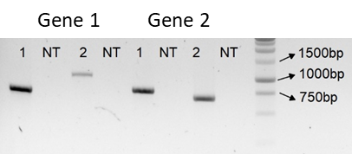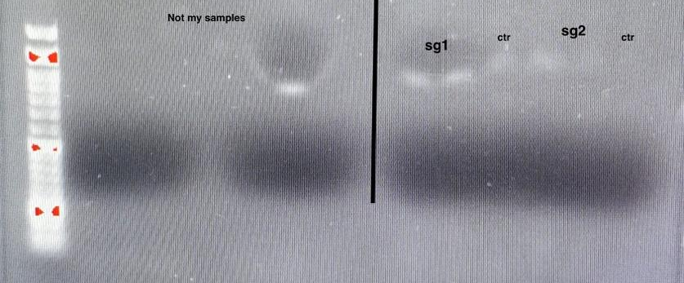
Example of real PCR outcomes. Left: Gene 1, amplicon 1 is good. Amplicon 2 is faint, and I would not use. Both Gene 2 products are good. Right: PCR and/or gel failed.
If you get a good result send for Sanger sequencing with both F and R primers (2 Sanger reactions). One reaction per primer. We will see which primer gives the best result.
Per tube add:
- 1 ul PCR product
- 6.5 ul MilliQ water
- 2.5 ul 10 uM primer
Tube code | Sample name | Primer
EF |  | F
EF |  | R

Sanger analysis—Wednesday
Import the .ab1 files into your ‘Target>Genotyping check’ folder.
The quality of the reads is highlighted in blue. Note that the first ~50 bases are low quality and the quality goes down with the length of the read. These errors can interfere with the next step, so we will trim poor quality regions from the reads.
Go to Annotate & Predict > Trim ends. Use the settings below.
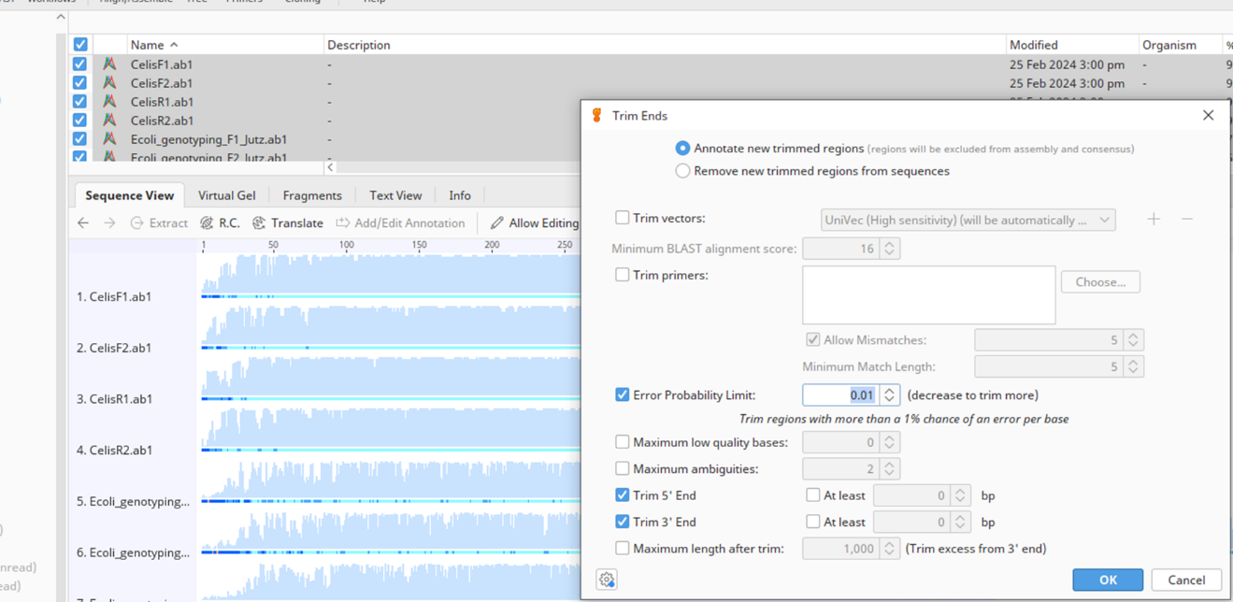
Select your trimmed reads and reference sequence.
Go to Align/Assemble > Map to Reference(s)… and use the following settings.
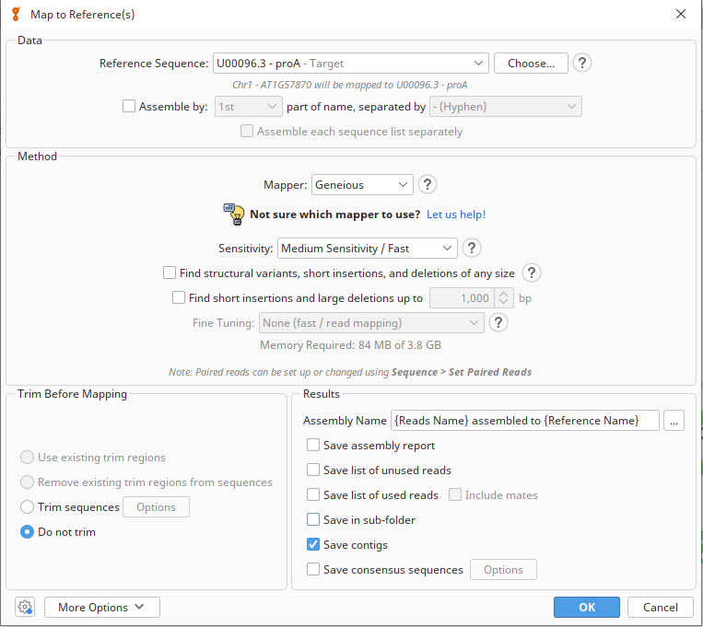
Be sure to select your gene target as the reference sequence.
Describe the Sanger sequencing results. Do you see any SNPs/indels? If so, where are they located? Is your crRNA sequence the same? Can you proceed with the experiment using this target? Which primer resulted in the best chromatogram? Choose this one for genotyping. Record it here:

Endogenous target Golden Gate reactions—Wednesday
Oligo annealing
Resuspend your oligos to a concentration of 100 µM.
For example, this oligo is 17.6 nmol. To make a 100 µM stock, add 176 µl of water or buffer (e.g. 10 mM Tris-HCl).
Steps:
- Spin tubes down w/ mini-centrifuge ~10 seconds
(this ensures the oligo pellet is at the bottom of the tube)
- Add correct amount of water or buffer
- Cap and mix by shaking and/or vortex
- Spin tubes down w/ mini-centrifuge ~10 seconds

Anneal oligos
- Add 1 µL of each 100 µM oligo to 48 µL of MQ water
- Incubate with a slow-cooling program on the thermal cycler e.g.: 5 minutes at 95°C; 95-85°C, -2°C/second; 85-25°C, -0.1°C/second
  - Alternatively, heat for 5 minutes at 95°C and slow cool on bench for ~5 minutes.
Golden Gate reaction
Component | Amount | Volume (µL)
Annealed oligos |  | 1
pGGP-ABE | 100 ng | 1
10X CutSmart Buffer | 1X | 1.5
10 mM ATP | 1 mM | 1.5
T4 DNA ligase | 200 U | 0.5
BbsI | 5 U | 0.5
MQ water |  | 9
 |  | 15
Thermal cycler program
37°C | 3 min | 25 x
16°C | 3 min | 25 x
50°C | 5 min
80°C | 5 min
16°C | ∞

Keep on ice or overnight in the -20.

E. coli Transformation
Tom’s E. coli transformation protocol
This is based on recommendations from NEB (scroll to product information>advantages and features). This should give the highest yield of transformants, but shortcuts can be taken at the underlined steps.
- Thaw E. coli cells on ice for 10 minutes.
- Add 2.5 µL of the Golden Gate reaction mix to 25 µL of chemical competent E. coli.
- Keep on ice 20-30 minutes (can be less).
- Heat shock at exactly 42°C for 30 seconds.
- Immediately chill on ice for 5 minutes.
- Add 300 µL pre-warmed (37°C) SOC (not necessary, but helps).
- Shake at 37°C for 20-60 minutes (20 minutes is minimum; for AmpR, can be skipped entirely).
- Plate 100 µL on pre-warmed (37°C) (not necessary, but helps) LB + Spec.
Following day, number of colonies:

Colony PCR of endogenous target—Thursday
We cannot tell if the cells are mutated just by looking at them, so we need to Sanger sequence to check for DNA mutations.
PCR protocol:
Component | 1x | 8x
Allin Red Taq 2xMM | 5 µL | 40
F primer 10 µM | 0.2 µL | 1.6
R primer 10 µM | 0.2 µL | 1.6
H₂O | 4.6 µL | 36.8
Total | 10 µL
Temp | Time
95°C | 3:00
95°C | :15 | 31X  cycles
60 °C | :15 | 31X  cycles
72°C | :30 | 31X  cycles
72°C | 5:00
12°C | ∞
5 colonies + 1 wild-type E. coli + 1 no-template (NT) control.
Record your expected PCR fragment size:
Perform a colony-touch PCR
- Aliquot 10 ul of PCR mix into the strip tubes.
- Spin down so the mix is on the bottom.
- Close your NT tube.
- Take a pipette tip (10 - 200 ul) with your fingers and touch it to the E. coli. Don't scoop.
- Dip the tip in your PCR mix. Mix it around a little and discard the tip.
- Cap the tubes and run the PCR.
Gel Electrophoresis
Load 4 µL of your PCR on gel and run for ~30 minutes.
Insert your annotated gel images.

If you get a good result, send for Sanger sequencing with the F or R primer (6 Sanger reactions).
Per tube add:
- 1 ul PCR product
- 6.5 ul MilliQ water
- 2.5 ul 10 uM primer
Tube code | Sample name | Colony
EF |  | 1
EF |  | 2
EF |  | 3
EF |  | 4
EF |  | 5
EF |  | WT

Sanger analysis—Friday
Import the .ab1 files into your ‘Target>Genotyping check’ folder.
The quality of the reads is highlighted in blue. Note that the first ~50 bases are low quality and the quality goes down with the length of the read. These errors can interfere with the next step, so we will trim poor quality regions from the reads.
Go to Annotate & Predict > Trim ends. Use the settings below.
Select your trimmed reads and reference sequence.
Go to Align/Assemble > Map to Reference(s)… and use the following settings.
Be sure to select your gene target as the reference sequence.
Describe the Sanger sequencing results. Do you see any SNPs/indels? If so, where are they located? Are they located within the editing window?
Go to EditR and upload your samples following the website instructions. Record your results. Replace ‘n’ with the position of the A in your target site.
Colony | An | An | An | An
1
2
3
4
5
WT

crRNA off-target reporter cloning
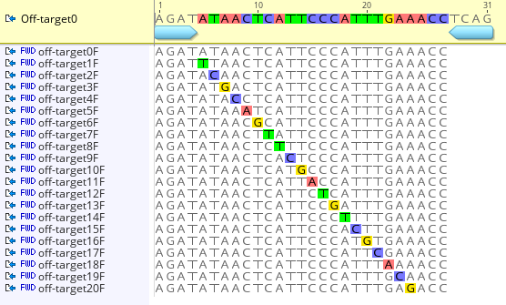
We are going to use a base editing reporter plasmid to evaluate which off-targets are tolerated by Cas12a. The reporter plasmid contains a point mutation at amino-acid 95 resulting in a premature stop codon (R95*). Adenine base editing (ABE) converts the stop codon into arginine and restores fluorescence. Point mutations have been designed along the entire length of the crRNA. We will clone these crRNAs into the base editing plasmid and co-transform it with the reporter plasmid.

Off-target Golden Gate cloning—Friday
The oligos have already been resuspended at 100 µM.
Record which pair of oligos you have:
Anneal oligos
- Add 1 µL of each 100 µM oligo to 48 µL of MQ water
- Incubate with a slow-cooling program on the thermal cycler e.g.: 5 minutes at 95°C; 95-85°C, -2°C/second; 85-25°C, -0.1°C/second
  - Alternatively, heat for 5 minutes at 95°C and slow cool on bench for ~5 minutes.
Golden Gate reaction
Component | Amount | Volume (µL)
Annealed oligos |  | 1
pGGP-ABE | 100 ng | 1
10X CutSmart Buffer | 1X | 1.5
10 mM ATP | 1 mM | 1.5
T4 DNA ligase | 200 U | 0.5
BbsI | 5 U | 0.5
MQ water |  | 9
 |  | 15
Thermal cycler program
37°C | 3 min | 25 x
16°C | 3 min | 25 x
50°C | 5 min
80°C | 5 min
16°C | ∞

Keep on ice or overnight in the -20.
E. coli Transformation
Tom’s E. coli transformation protocol
This is based on recommendations from NEB (scroll to product information>advantages and features). This should give the highest yield of transformants, but shortcuts can be taken at the underlined steps.
- Thaw E. coli cells on ice for 10 minutes.
- Add 2.5 µL of the Golden Gate reaction mix AND 1 ul of the Reporter plasmid (10 ng/ µL) to 25 µL chemical competent E. coli.
- Keep on ice 20-30 minutes (can be less).
- Heat shock at exactly 42°C for 30 seconds.
- Immediately chill on ice for 5 minutes.
- Add 300 µL pre-warmed (37°C) SOC (not necessary, but helps).
- Shake at 37°C for 20-60 minutes (20 minutes is minimum; for AmpR, can be skipped entirely).
- Plate 300 µL on pre-warmed (37°C) (not necessary, but helps) LB + Spec + Gent.
Following day, number of colonies:

Fluorescent colony counts—Tuesday
To get a measure on off-target activity, we are going to count the number of fluorescent colonies. Select 50 colonies under normal light, and then check them under the binocular fluorescence microscope if they are fluorescent or not.
The colonies should look like this
Record the number of fluorescent colonies:
Do you see any variation in fluorescence intensity or patterns? Record your results here.

Colony PCR of reporter—Tuesday
We now know if the cells are fluorescent or not. We are now asking if DNA mutations are present.
PCR protocol:
Component | 1x | 8x
Allin Red Taq 2xMM | 5 µL | 40
1651 10 µM | 0.2 µL | 1.6
1652 10 µM | 0.2 µL | 1.6
H₂O | 4.6 µL | 36.8
Total | 10 µL
Temp | Time
95°C | 3:00
95°C | :15 | 30X  cycles
60 °C | :15 | 30X  cycles
72°C | :30 | 30X  cycles
72°C | 5:00
12°C | ∞
5 samples + 1 reporter plasmid control + 1 no-template (NT) control.
Record your expected PCR fragment size:
Perform a colony-touch PCR
- Aliquot 10 ul of PCR mix into the strip tubes.
- Spin down so the mix is on the bottom.
- Close your NT tube.
- Add 1 ul of the plasmid control (1 ng/ul)
- Take a pipette tip (10 - 200 ul) with your fingers and touch it to the E. coli. Don't scoop.
- Dip the tip in your PCR mix. Mix it around a little and discard the tip.
- Cap the tubes and run the PCR.

Gel electrophoresis—Wednesday
Load 4 µL of your PCR on gel and run for ~30 minutes.
Insert your annotated gel images.

If you get a good result, send for Sanger sequencing with the 1652 primer (6 Sanger reactions).
Per tube add:
- 1 ul PCR product
- 6.5 ul MilliQ water
- 2.5 ul 10 uM 1652 primer
Tube code | Sample name | Colony
EF |  | 1
EF |  | 2
EF |  | 3
EF |  | 4
EF |  | 5
EF |  | WT

Reporter Sanger analysis—Thursday
Import the .ab1 files into your ‘Reporter off-target’ folder.
The quality of the reads is highlighted in blue. Note that the first ~50 bases are low quality and the quality goes down with the length of the read. These errors can interfere with the next step, so we will trim poor quality regions from the reads.
Go to Annotate & Predict > Trim ends. Use the settings below.
Select your trimmed reads and reference sequence (Reporter plasmid).
Go to Align/Assemble > Map to Reference(s)… and use the following settings.
Be sure to select the Reporter plasmid as the reference sequence.
Describe the Sanger sequencing results. Do you see any SNPs/indels? If so, where are they located? Are they located within the editing window?
Go to EditR and upload your samples following the website instructions. Record the percentage of A-to-G edits at the target sites:
Clone | A4 | A8 | A14
1
2
3
4
5

